PROJECT-47
AI Keyword Generator
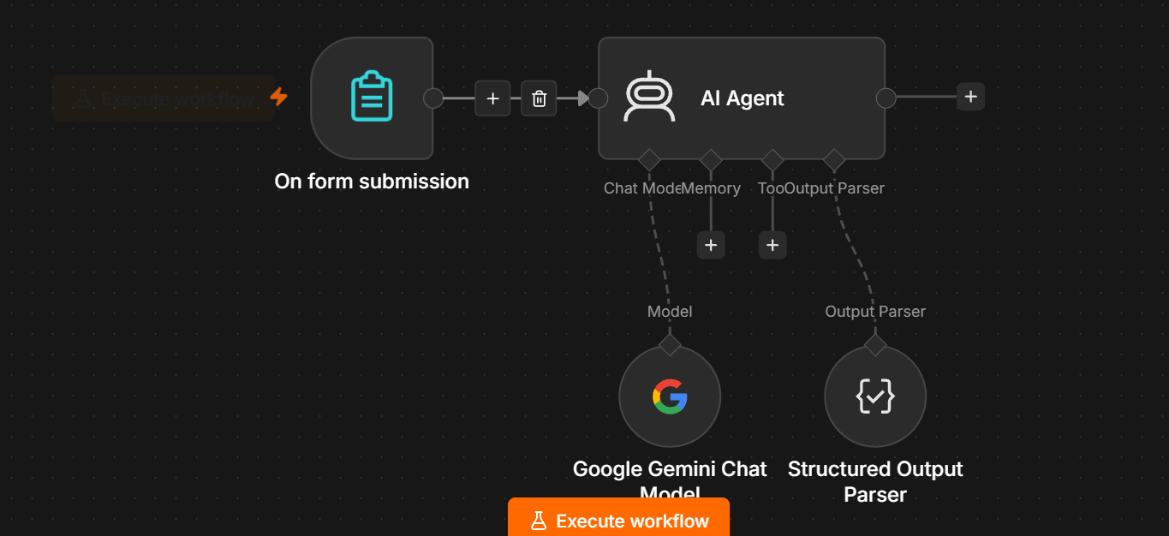
AI Keyword Generator — n8n Documentation
For your medium-level AI Agent practice, build this one using the same simple structure.
You do NOT need a Vector Store. ✅
On Form Submission
↓
AI Agent
↙ ↘
Gemini Output Parser

1. Project Objective
The AI Keyword Generator takes a topic, product, or business description and automatically generates relevant SEO keywords.
It can generate:
- Primary keywords
- Secondary keywords
- Long-tail keywords
- Question-based keywords
- Related keywords
- Search intent
- Keyword suggestions
- Content ideas

2. Nodes Required
Add only:
Main workflow
- On Form Submission
- AI Agent
AI Agent connections
- Google Gemini Chat Model
- Structured Output Parser
You DON'T need:
❌ Vector Store
❌ Data Loader
❌ Text Splitter
❌ Embeddings

3. Step 1 — On Form Submission
Add:
On Form Submission
Create these fields.
Field 1 — Topic
Type: Text
Topic
Example:
Digital Marketing

Field 2 — Target Audience
Type: Text
Target Audience
Example:
Small business owners

Field 3 — Location
Type: Text
Target Location
Example:
India
If the business is not location-specific, the user can enter:
Global

Field 4 — Business/Product Description
Type: Text Area
Business Description
Example:
We provide digital marketing services for small businesses,
including SEO, social media marketing and content marketing.

Field 5 — Keyword Purpose
Type: Dropdown or Text
Keyword Purpose
Recommended options:
Informational
Commercial
Transactional
Local
For a beginner, you can use Text first.

4. Form Example
Your form will look like:
Topic:
Digital Marketing

Target Audience:
Small business owners

Target Location:
India

Business Description:
We provide digital marketing services for small businesses,
including SEO, social media marketing and content marketing.

Keyword Purpose:
Commercial

5. Step 2 — AI Agent
Connect:
On Form Submission
↓
AI Agent
In the AI Agent, select:
Define below
for the user prompt.
Use:
Generate SEO keywords based on the following information.

Topic:
{{ $json['Topic'] }}

Target Audience:
{{ $json['Target Audience'] }}

Target Location:
{{ $json['Target Location'] }}

Business Description:
{{ $json['Business Description'] }}

Keyword Purpose:
{{ $json['Keyword Purpose'] }}

Generate:

1. Primary keywords
2. Secondary keywords
3. Long-tail keywords
4. Question-based keywords
5. Related keywords
6. Search intent for the keywords
7. Suggested content topics

Make the keywords relevant to the topic, audience,
location and intended purpose.

6. Step 3 — System Message
Use:
You are an AI SEO Keyword Research Assistant.

Your job is to generate relevant SEO keyword ideas based on
the user's topic, audience, location and business description.

IMPORTANT RULES:

1. Generate keywords relevant to the provided topic.
2. Consider the target audience.
3. Consider the target location when provided.
4. Match the requested keyword purpose.
5. Avoid duplicate keywords.
6. Do not generate unrelated keywords.
7. Include a mixture of broad and specific keywords.
8. Generate natural long-tail keywords.
9. Generate useful question-based keywords.
10. Identify the likely search intent.
11. Do not claim actual search volume or keyword difficulty
unless real keyword research data is provided.
12. Do not invent search volume numbers.
13. Return the result using the required structured output format.
Important
This rule is important:
Do not claim actual search volume or keyword difficulty.
Gemini can generate keyword ideas, but without a real SEO data source/API, it does not have reliable live search-volume data.

7. Step 4 — Google Gemini Chat Model
Add:
Google Gemini Chat Model
Connect it to the AI Agent's:
Chat Model
Correct connection:
Google Gemini Chat Model
↓
Chat Model
↓
AI Agent

8. Step 5 — Structured Output Parser
Add:
Structured Output Parser
Connect it to the AI Agent's:
Output Parser
AI Agent
↓
Output Parser
↓
Structured Output Parser

9. JSON Output Format
Use Generate from JSON Example.
Paste:
{
"topic": "Digital Marketing",
"primary_keywords": [
"digital marketing",
"digital marketing services",
"digital marketing agency"
],
"secondary_keywords": [
"SEO services",
"social media marketing",
"content marketing",
"online advertising"
],
"long_tail_keywords": [
"digital marketing services for small businesses",
"best digital marketing agency for small businesses",
"affordable digital marketing services in India"
],
"question_keywords": [
"What is digital marketing?",
"How does digital marketing help small businesses?",
"How to choose a digital marketing agency?"
],
"related_keywords": [
"online marketing",
"search engine optimization",
"social media strategy"
],
"search_intent": {
"primary": "Commercial",
"secondary": [
"Informational",
"Transactional"
]
},
"content_topics": [
"Digital Marketing Strategies for Small Businesses",
"How to Choose a Digital Marketing Agency",
"SEO vs Social Media Marketing"
]
}

10. Complete Workflow
Your canvas should look like:
┌─────────────────────────┐
│ On Form Submission │
│ │
│ Topic │
│ Target Audience │
│ Target Location │
│ Business Description │
│ Keyword Purpose │
└────────────┬────────────┘
│
▼
┌─────────────┐
│ AI Agent │
└──────┬──────┘
│
▼
Structured Output Parser
And:
Google Gemini Chat Model
↓
AI Agent

11. Test It
Use this information.
Topic
Digital Marketing
Target Audience
Small business owners
Target Location
India
Business Description
We provide digital marketing services for small businesses,
including SEO, social media marketing and content marketing.
Keyword Purpose
Commercial

12. Expected Output
You should receive something similar to:
{
"topic": "Digital Marketing",
"primary_keywords": [
"digital marketing services",
"digital marketing agency",
"digital marketing company"
],
"secondary_keywords": [
"SEO services",
"social media marketing",
"content marketing"
],
"long_tail_keywords": [
"digital marketing services for small businesses",
"affordable digital marketing agency in India",
"best digital marketing company for small businesses"
],
"question_keywords": [
"How does digital marketing help small businesses?",
"How to choose a digital marketing agency?"
],
"related_keywords": [
"online marketing",
"SEO",
"social media strategy"
],
"search_intent": {
"primary": "Commercial",
"secondary": [
"Informational",
"Transactional"
]
},
"content_topics": [
"Digital Marketing Strategies for Small Businesses",
"How to Choose a Digital Marketing Agency"
]
}
The exact keywords will vary. That's normal.

13. Understanding the Output
Primary Keywords
The main keywords you want to target.
Example:
digital marketing agency
Secondary Keywords
Related terms that support the primary topic.
SEO services
social media marketing
content marketing
Long-Tail Keywords
More specific search phrases.
digital marketing services for small businesses
Question Keywords
Questions people may search.
How does digital marketing help small businesses?
Related Keywords
Semantically related terms.
online marketing
SEO
social media strategy

14. Search Intent
The AI can classify intent as:
Informational
User wants information.
Example:
What is digital marketing?
Commercial
User is researching a product/service.
Example:
Best digital marketing agency in India
Transactional
User is ready to take action/buy.
Example:
Hire a digital marketing agency
Local
User is looking for a service in a specific location.
Example:
Digital marketing agency near Hyderabad

15. Second Test
Try:
Topic
Running Shoes
Target Audience
Beginner runners
Target Location
India
Business Description
We sell affordable running shoes designed for beginners
and daily jogging.
Keyword Purpose
Commercial
You should get keywords similar to:
running shoes for beginners
best running shoes for beginners
affordable running shoes
running shoes for daily jogging
running shoes for beginners in India

16. Important Limitation
Your current AI Keyword Generator generates keyword ideas.
It does not provide reliable:
- Search volume
- Keyword difficulty
- CPC
- Competition
- Current Google rankings
Don't add fields like:
search_volume: 50,000
keyword_difficulty: 72
unless you're connecting an actual keyword research data source.
For a medium-level n8n project, keyword generation + intent + content ideas is sufficient.

17. Optional Advanced Version
Later, you can connect a real SEO data API:
On Form Submission
↓
AI Keyword Generator
↓
Keyword List
↓
SEO API
↓
Search Volume
Keyword Difficulty
CPC
Competition
↓
AI Agent
↓
Best Keyword Selection
Then your system becomes a much more advanced AI SEO Keyword Research Agent.

18. Final Project Summary
Input
Topic
Target Audience
Location
Business Description
Keyword Purpose
Processing
Google Gemini
+
AI Agent
+
Prompt Engineering
Output
Primary Keywords
Secondary Keywords
Long-Tail Keywords
Question Keywords
Related Keywords
Search Intent
Content Topics
Final Architecture
On Form Submission
↓
AI Agent
↙ ↘
Gemini Output Parser
↓
Structured JSON
This is a good medium-level AI Agent project, and like the Product Description Generator, you do not need a Vector Store.

